Final Delivery

Calvin Hong – 431518



# Introduction

This semester was focused on AI for Society. Students had to work on a group project and individual project.

The parents of the student run a snack bar, which was a unique advantage that was used for this project. At the moment, the snack bar has multiple points that could be improved during the process of preparing an order. One of the major bottlenecks that could be improved with artificial intelligence is the gathering of the items for an order.

The final idea: **Snack bar preparation assistant**

The assistant AI will scan new receipts as soon as they get ordered and show the employee what items should be prepared first. This should help with the time efficiency, since not all the items cook in the same amount of time. For example, a hamburger takes around 10 minutes, while a frikandel takes around 5. Having a screen that shows you what you should prepare in order of time should make the process more time efficient.

Some items are also not in the front deli case at the work station. To get these items the employee has to go to the back. This sometimes results in having to make multiple trips because it is difficult to remember all the items listed. The assistant can group these items together in an overview so that it is clearer for the employee.

In this final delivery, all the work done in this project has been document. In the chapter: GitHub Links, important links are given.

Contents

Introduction 2

Project components 4

Scanner 4

Backoffice 10

Dashboard 18

Hosting 21

GitHub links 23

Live Action 24

Follow up suggestions 25

Conclusion 26

# Project components

To achieve the desired outcome, which could be developed further on in the future, multiple aspects come into play.

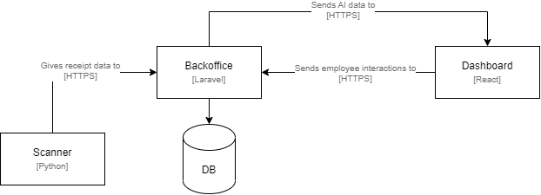

Figure project diagram

In the diagram above, the parts of the system is displayed.

## Scanner

The scanner is the starting point of the process. When a customer orders a meal, the cashier creates a new order in the cash register. In the ideal situation, the cash register could be connected a system where is could be saved. However, the cash register used is an older model that cannot do this. Because of this, a scanner was created that could scan the receipts.

#### Structure Scanner

The scanner consists out of a Raspberry Pie connected to a camera.

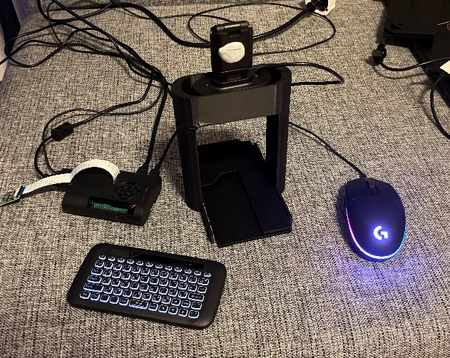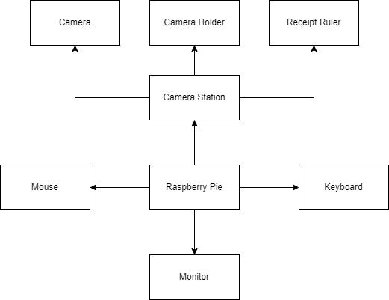

Figure picture scanner setup

Figure scanner diagram

In the diagram and picture above, you can see the final prototype result of the scanner. At the center is the Raspberry Pie, which is connected to the Backoffice. Besides being wired to the necessities (keyboard, mouse and monitor), it is also connected to a camera station where the receipts get scanned. This station consists out of three main parts: a camera, camera holder, and receipt ruler.

On the receipt itself, there was much data that was unnecessary, so an additional custom receipt “ruler” was made. This ruler blocks the data that was not needed, like the address and phone number of the snack bar. See the picture below.

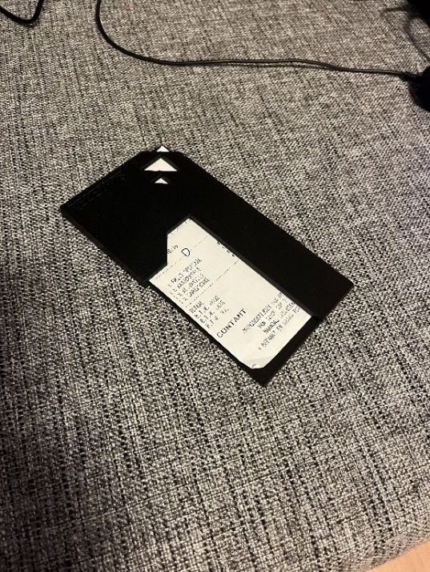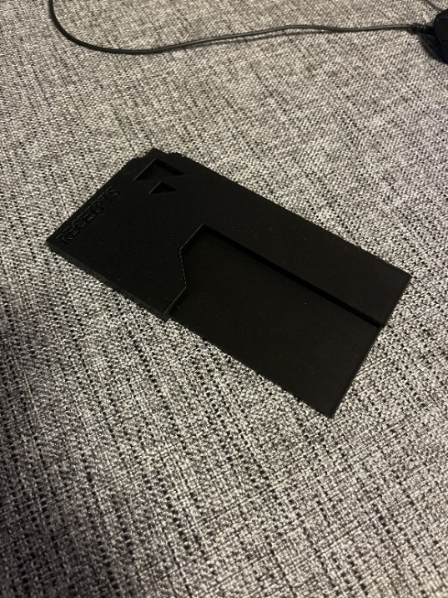

Figure receipt ruler with receipt

Figure receipt ruler without receipt

The initial idea was to use a Raspberry Pie camera, but unfortunately this was not ideal to use. The focus length was not adjustable and the cable was too short (see figure 7).

To overcome this issue, an adjustable webcam was used together with a 3D printed holder to keep the distance consistent. The lens could be rotated to adjust the focus/sharpness (See the figure 6).

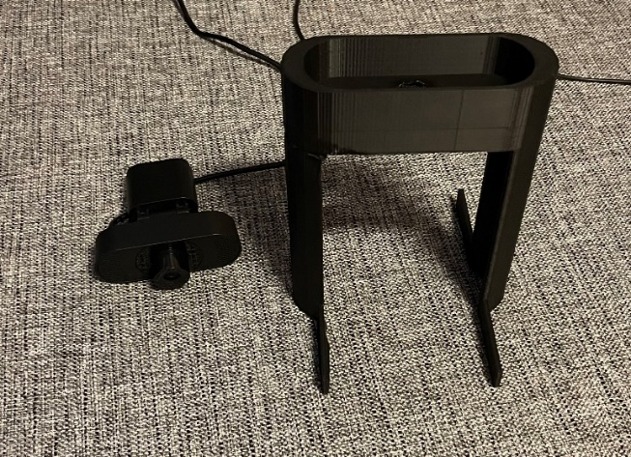 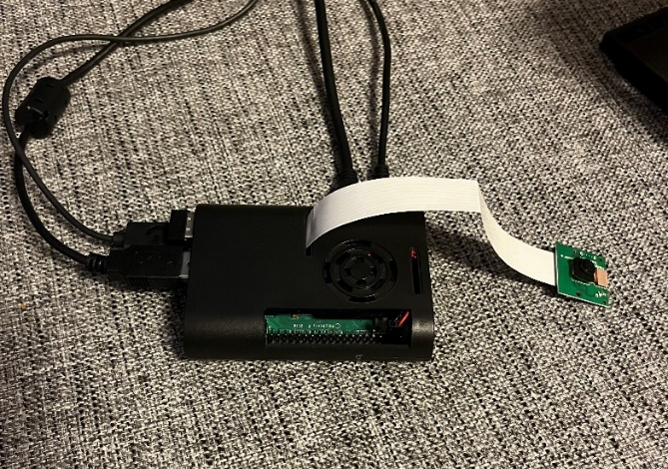

Figure camera with camera holder

Figure raspberry pi with small camera

Using this setup, the system could start scanning receipts.

#### Python-Tesseract

To get the data on the receipts, Python-Tesseract, or just Tesseract, was used. Tesseract is an optical character recognition (OCR) tool that can be used with python. It can get/read the text on images.

Before Tesseract was used to actually get the receipt data, the image first had to be improved. The unedited receipt image looks like this:

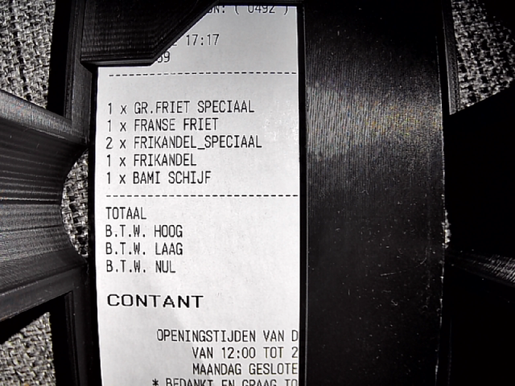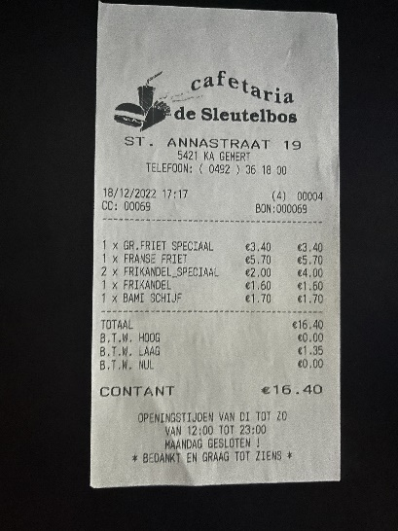

Figure receipt in ruler from camera holder view

Figure normal receipt

OCR systems like to use black and white (0,1) instead of full color(0,255), so the first step was to convert the image to black and white. After this, the gaps were filled in as much as possible, which resulted in the following:

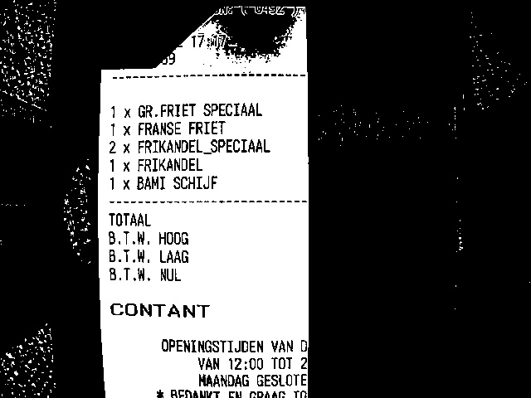

Figure inverted image

With the improved image, Tesseract now comes into play. When passing along the image, one can also change some configurations. One of the most important setting is PSM, or Page Segmentation Modes. By default, Tesseract expects to receive a block of text, but the image we are providing it is far from a page of text though. By changing the PSM we can change the expectation of Tesseract and in turn change the outcome of the data we receive. A full list of the available modes can be found by looking it up online or by using the command

This will return:

Page segmentation modes:

0 Orientation and script detection (OSD) only.

1 Automatic page segmentation with OSD.

2 Automatic page segmentation, but no OSD, or OCR. (not implemented)

3 Fully automatic page segmentation, but no OSD. (Default)

4 Assume a single column of text of variable sizes.

5 Assume a single uniform block of vertically aligned text.

6 Assume a single uniform block of text.

7 Treat the image as a single text line.

8 Treat the image as a single word.

9 Treat the image as a single word in a circle.

10 Treat the image as a single character.

11 Sparse text. Find as much text as possible in no particular order.

12 Sparse text with OSD.

13 Raw line. Treat the image as a single text line,

bypassing hacks that are Tesseract-specific.

By using PSM 4 (assume a single column of text of variable sizes), we change the expectation and in turn change the data we receive. Using the wrong PSM could result in wrong data or no data at all. Alongside the PSM, we also give the image itself and what kind of output we want. The code looks like this:



For example, if you give the configuration PSM 7 (Assume a single uniform block of text) to Tesseract, the results differs a lot (even with the same image).

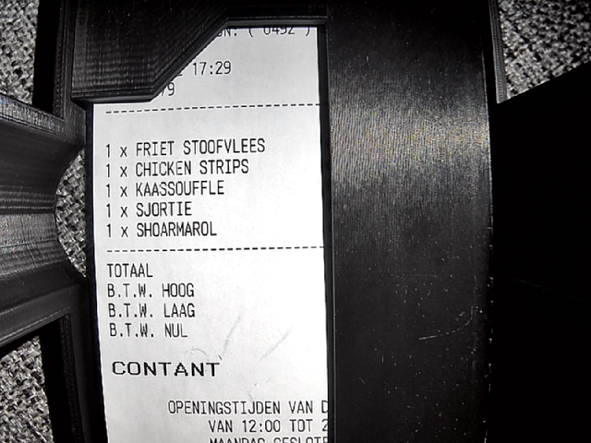

Figure receipt in ruler from camera holder view 2

PSM 4: PSM 7

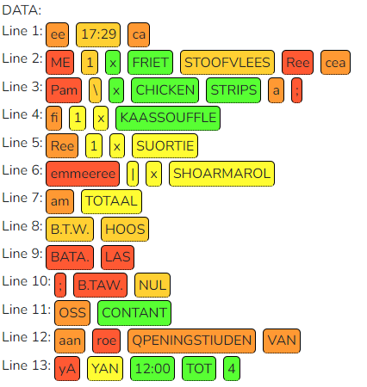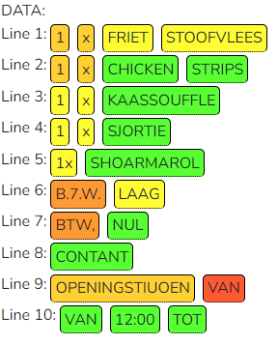

Figure data from psm 7

Figure data from psm 4

#### Tensorflow

Tesseract is not the only form of AI/Machine Learning in this project. The data could be incorrect if the receipt is adjusted by hand/pen, so a warning should be given. Furthermore, the snack bar has 2 different cash registers with different printers. One for phone orders, and one for one-site orders. These receipts look different, so to distinguish them and see if they are adjusted, Tensorflow is used.

Employees can manually adjust receipts using a pen after it has already been printed, but not scanned yet (see figure 14).

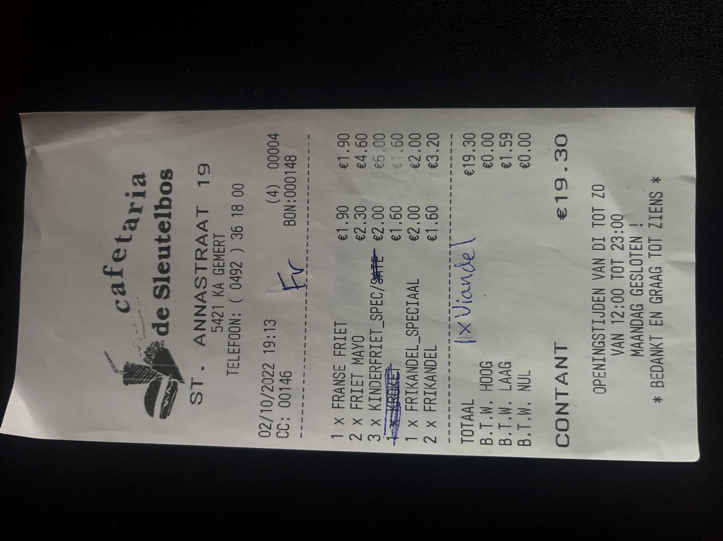

Figure pen adjusted receipt

The scanner (Python-Tesseract) is not able to accurately record this pen data. To prevent a receipt from being not used by the system, a warning will be given on the dashboard if it is adjusted. To check, Tensorflow is used to predict if a receipt is adjusted.

Tensorflow is an end-to-end platform used for building and deploying machine learning models. This ML model is connected to the scanner, so the prediction of the AI gets sent together with the image and text data.

A document that goes further into the created ML model can be found here: <https://github.com/cafetaria-sleutelbos/Documents/tree/main/Tensorflow>

All this data then gets send to the Backoffice.

## Backoffice

The Backoffice stands in the center of the system. It is created with the PHP framework Laravel. In here the scans, orders and items can be seen and adjusted. The database structure looks like the following:

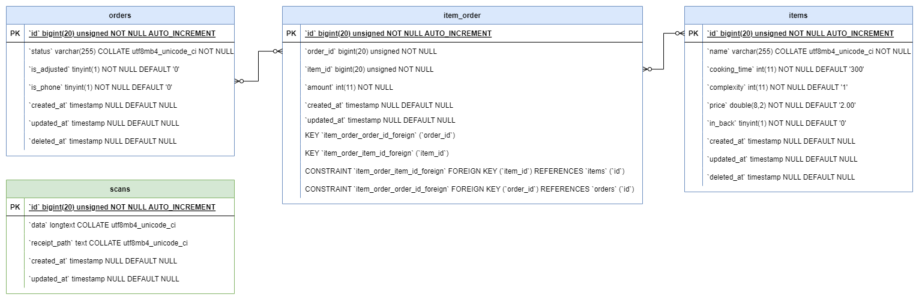

Figure basic database structure

scans: The received text data with the confidence. Also the path where the image is saved.

*orders*: keeps track of orders with its items through the link table *item_order.* Has status column which can be: WAITING, IN_PROGRESS or FINISHED. Also has columns for adjusted or phone.

item_order: pivot table for Order Items

items: product/item (e.g. fries with mayo, burger, drink, etc). Has the default columns like *name, cooking_time, and price.* The column *in_back* keeps track of if the item is in the back. For these items, a notification must be given to the employee. The *complexity* is how hard it is to prepare.



Figure complexity

For the items, a database seeder is made so that all the items (currently a total of 252 items) do not have to be created one by one, but can be created automatically in one go.

With all this preparation, the scan can be processed.

#### Processing scans

When a scan gets received, the Backoffice first breaks it down into steps:

##### 1 Store Image

To create the image dataset that Tensorflow uses, we have to save the scanned receipt as images. This image gets stored in Laravel Storage. Through the scan index view, all the images can be downloaded as a .zip file. The images themselves can also be viewed in the scan show view.

##### 2 Store scan data

The data received then gets stored in a *Scan* model. The image path also gets saved in this model

##### 3 Turn text/scan data into JSON format

The scan data was received as a JSON as string. This data first has to be converted back into JSON format to be useful.

##### 4 Create an *Order* model

After the image and scan model are created, an Order model can be created. Order models keep track of the status and the linked items/products. This new order model will be used next to link items.

##### 5 Loop over JSON object

The newly created order is currently empty. To link items to the order, we first need to know which and how many items were found in the scan. A JSON object is split up into multiple lines. These lines will be looped over, since they have the item amount and name. One line looks like this:



The first step is to implode the nested array with only the string values.



This results in the string “*2xBAMJSCHIJR*” which then can be split into amount: “*2*” and name: “*BAMJSCHIJR*”. If the amount is not an integer, it defaults to 1. The same goes for amounts above 99. The name is not always as accurate, as seen in this example. The correct name is: BAMISCHIJF. To overcome this problem, the method levenshtein is used. This method basically loops over an existing array and tries to match the closest string with the least amount of differences. If no items are found, the item “diverse” gets returned.

##### 8 Attach item to order

The found item finally gets linked to the order.

##### 9 Return response to scanner

If all goes well, a 200 response gets returned to the scanner.

After this whole process, the result is: A scan model, scanned image, and an order model linked to items.

#### Views

The Backoffice also has a UI so that scans/orders/items can be easily viewed or adjusted (basic CRUD).

##### Login

The authentication was made with the help of Laravel Jetstream. Because of this, only authenticated and not random users can adjust models.

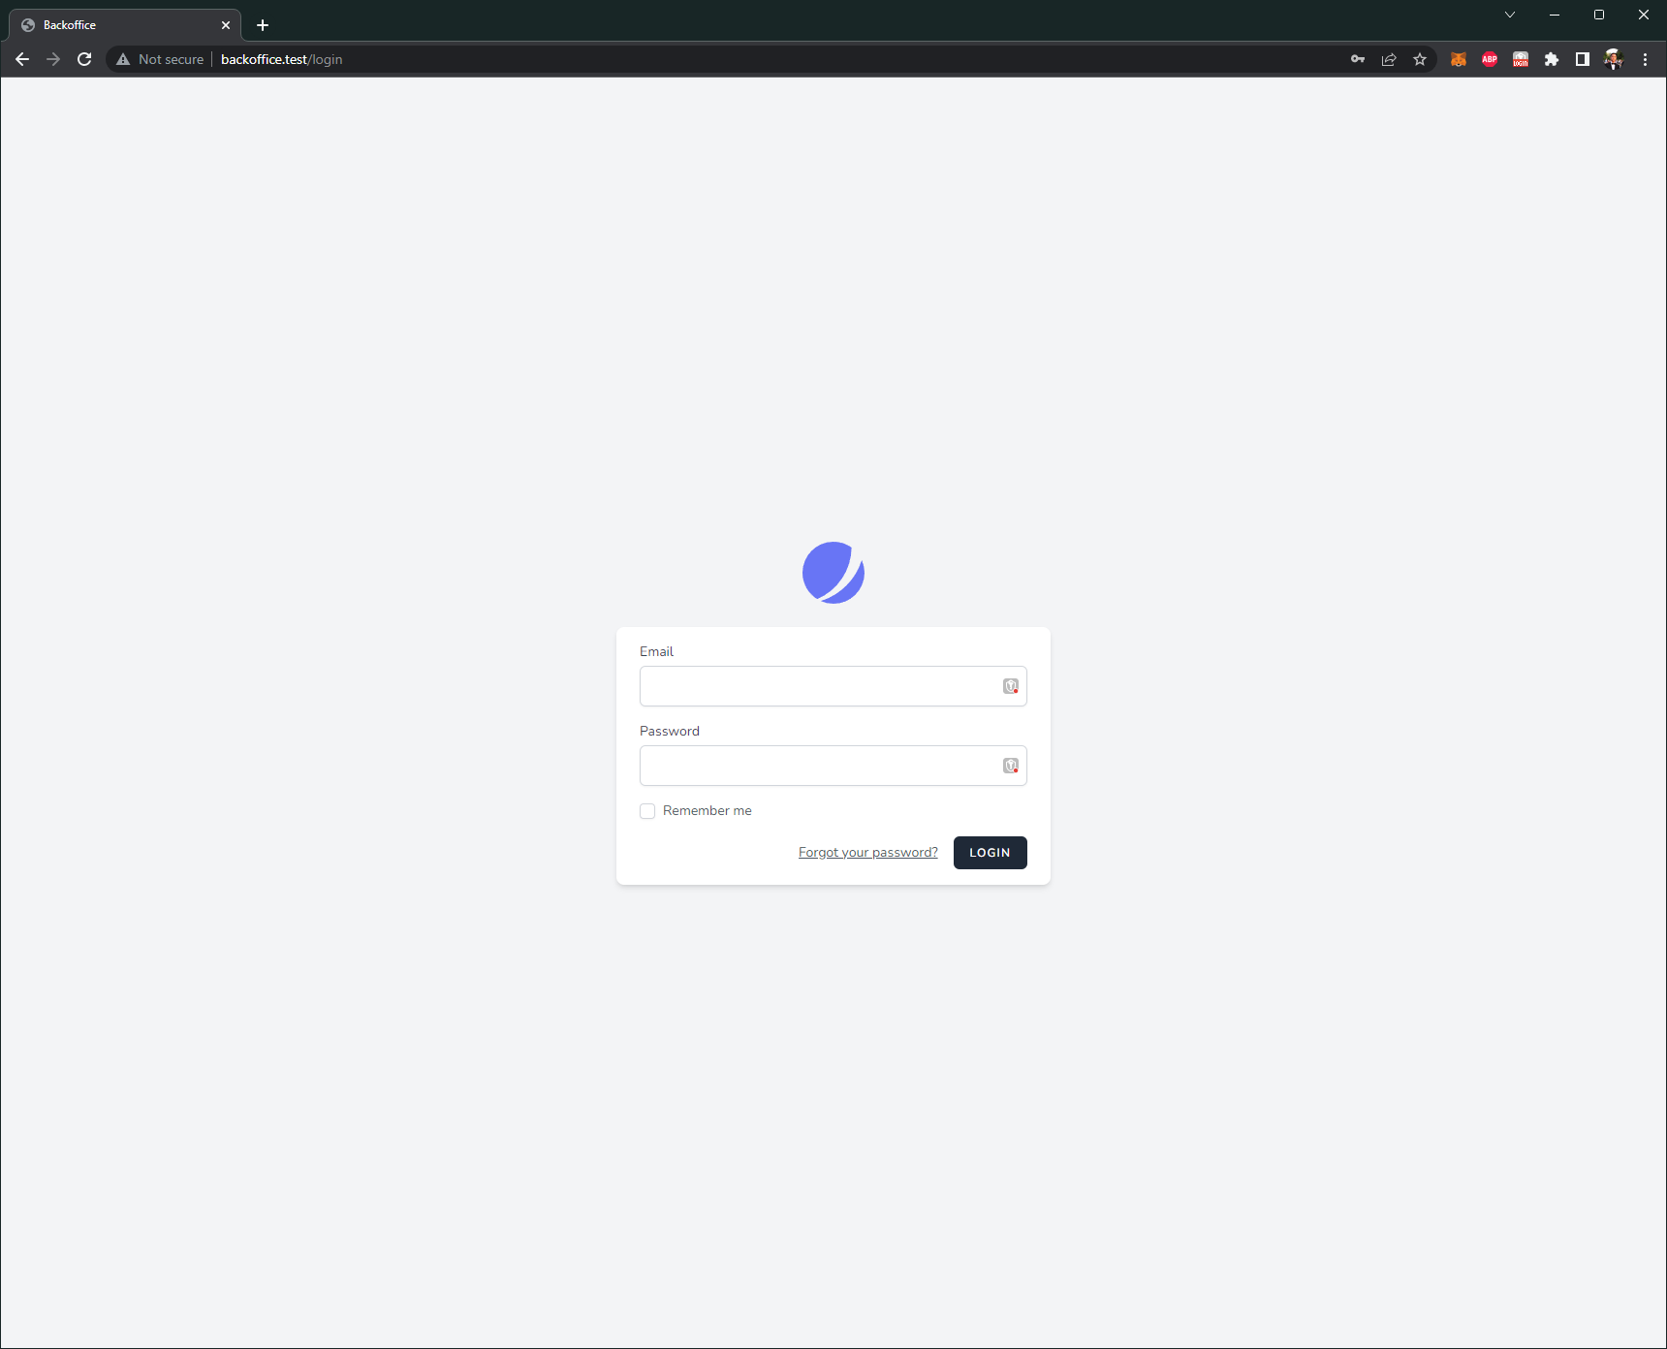

Figure login screen

##### Models

After logging in, the CRUDs can be accessed. Each model has their own views, which are separated in: Index (all models), show (one specific model), and a form (to create a new model or adjust one).

###### Scans

First off, the scans. In the *scans index view*, all the scan models can be found. It is displayed in a table, using the library DataTables.

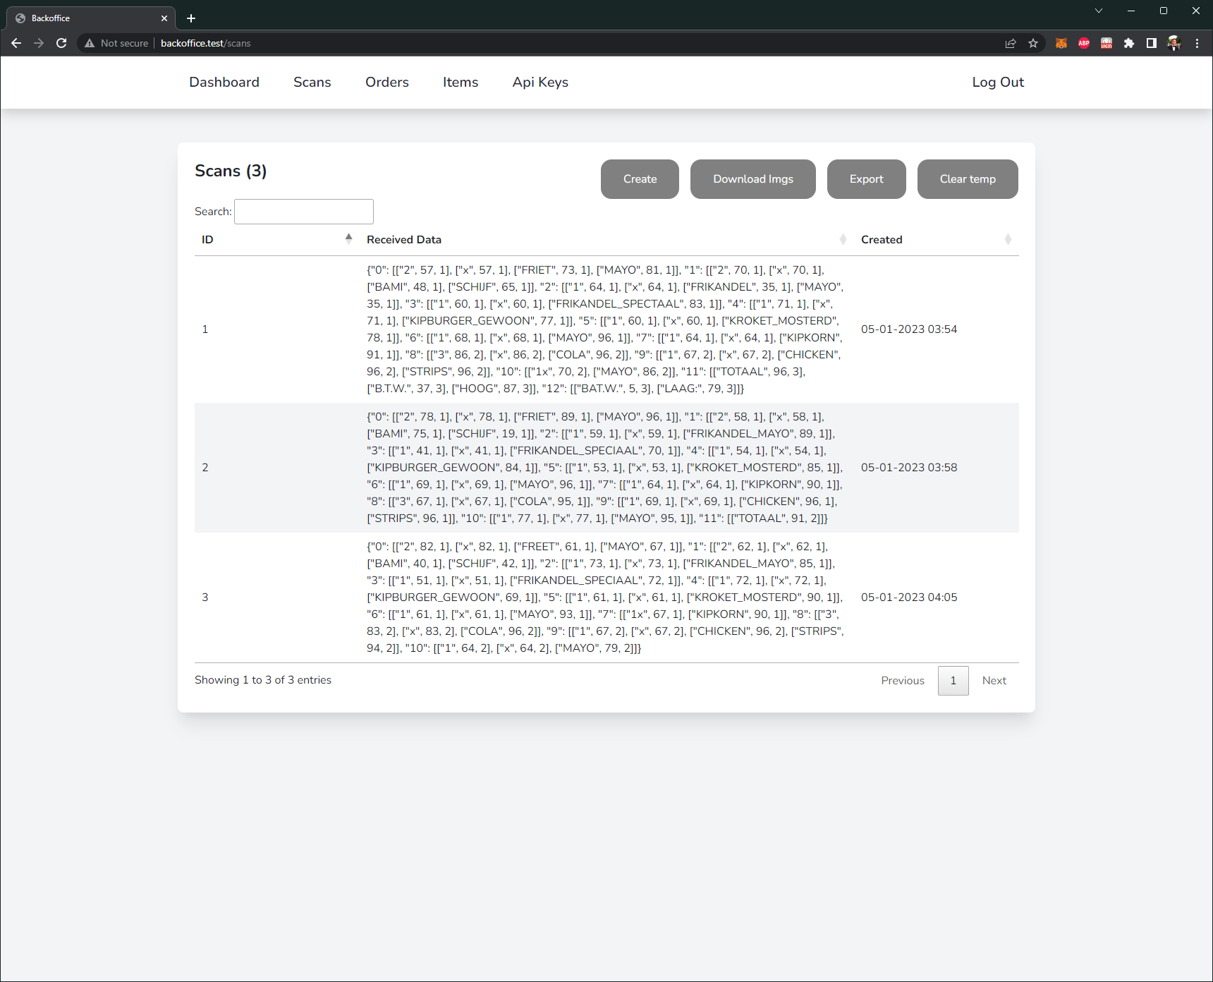

Figure scan index view

On the top right of the card, the action buttons can be found. The “*Create*“ button is used for creating new scans. The “*Download imgs*” button is used for exporting all the images as a zip file. This is used for creating the image dataset for Tensorflow. The “*Export*” button is used for exporting all the scan data as an csv file. And finally the “*Clear temp*” button. This button is used for clearing all the images and zip files that are stored in Laravel Storage so that it does not built up too much.

The DataTable also has functions. Scans can be searched for using the search bar on the top left of the table. Besides this, each column can be sorted, from high to low. The standard sort function is the ID column from low to high. The page lengths are set to 25 items. If there are more than 25 items, the pagination buttons on the bottom right of the table can be used.

A row can be clicked on to view individual scans. This page is called the *scan show view*. In this show view, more information can be found.

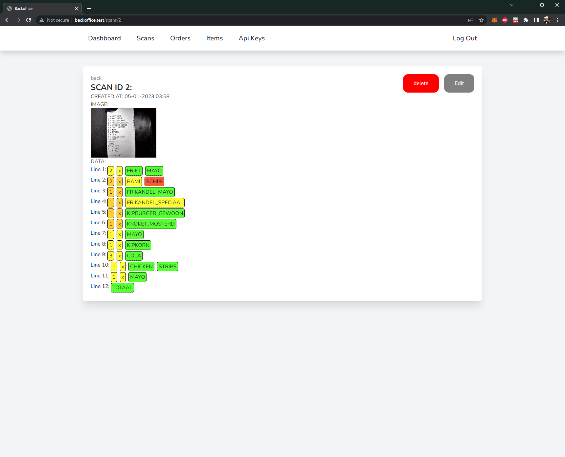

Figure scan show view

On the top left of the card, a back button is placed to quickly go back to the previous page. Below this button, the scan data is displayed. In order from top to bottom:

**The scan ID:** This value displays the unique identification number.

**Created at date:** The date and time when the model was created.

**The scanner image:** The image received from the scanner.

**The data:**

The data received from the scanner. Instead of just displaying the raw data as a string, it has been split by line. Each word is then also displayed with a color. This color is the Tesseract confidence of the data. This confidence number (0-100) can be seen by hovering over the word itself.

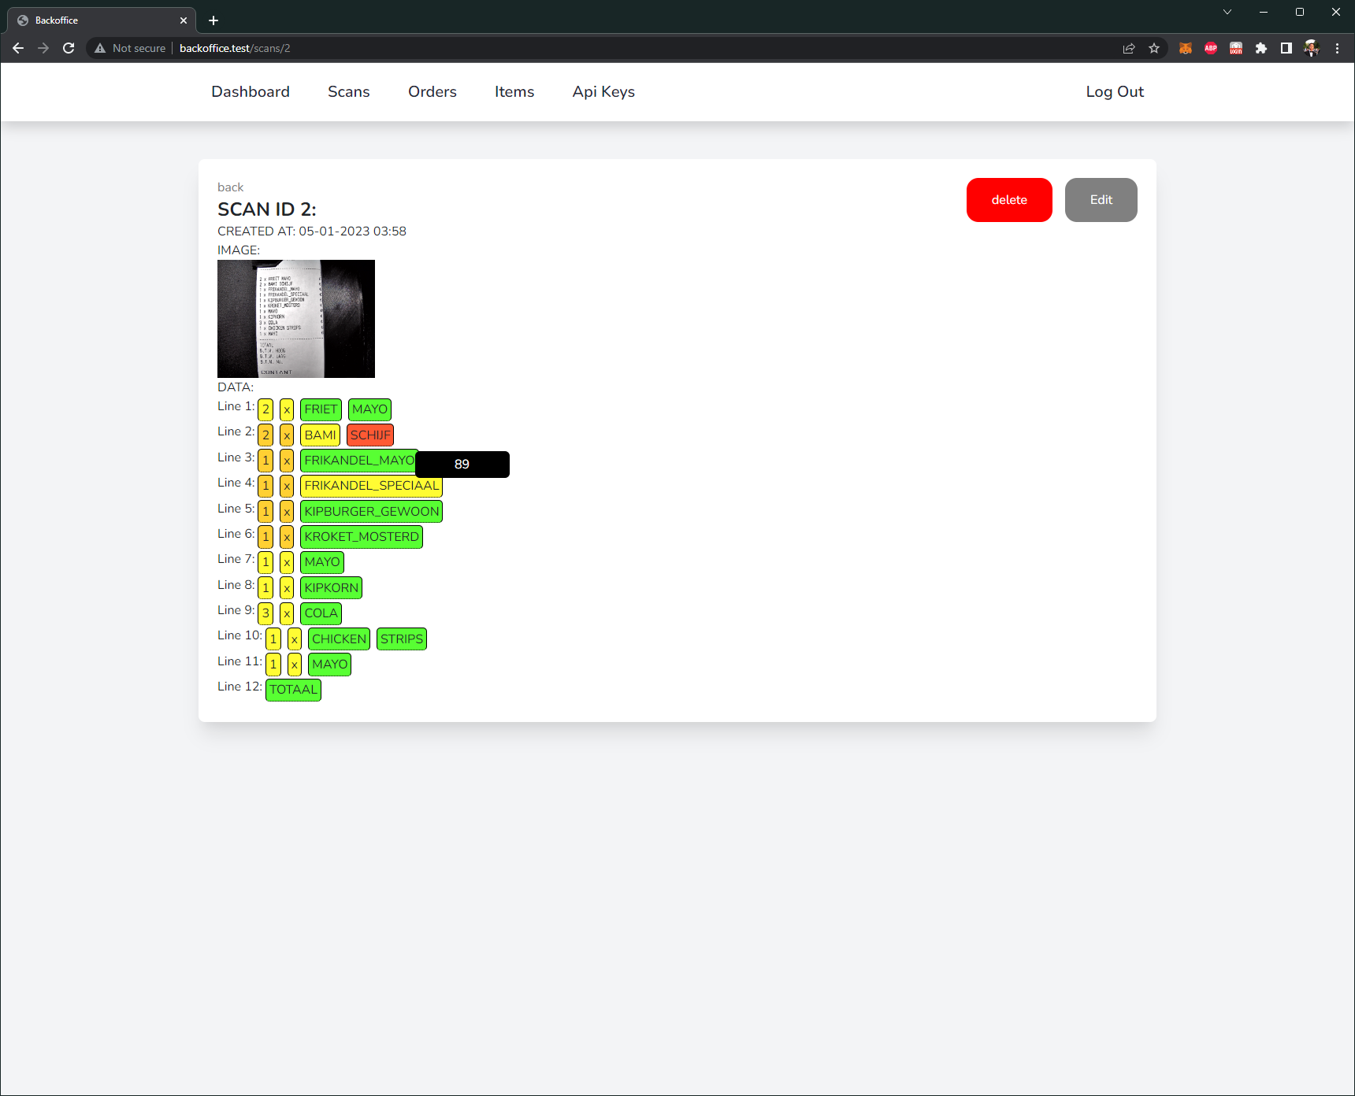

Figure hover data

On the top right of the card, there are two buttons. One for deleting a scan and one for editing a scan. The edit form can be seen in the image below.

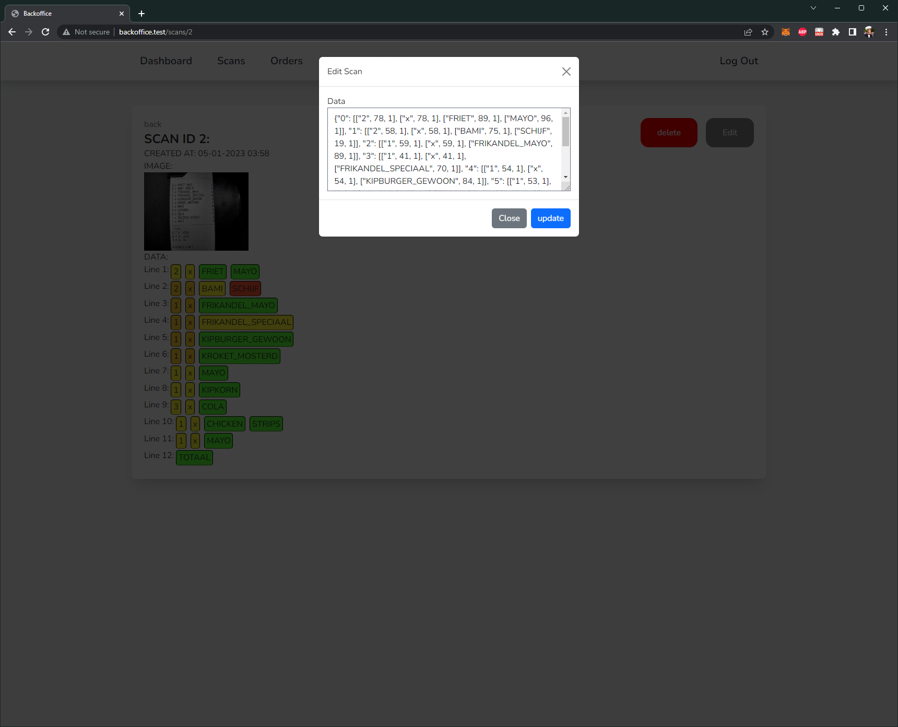

Figure scan form

The views for orders and items look somewhat similar and have the same basic functionalities.

Order index view

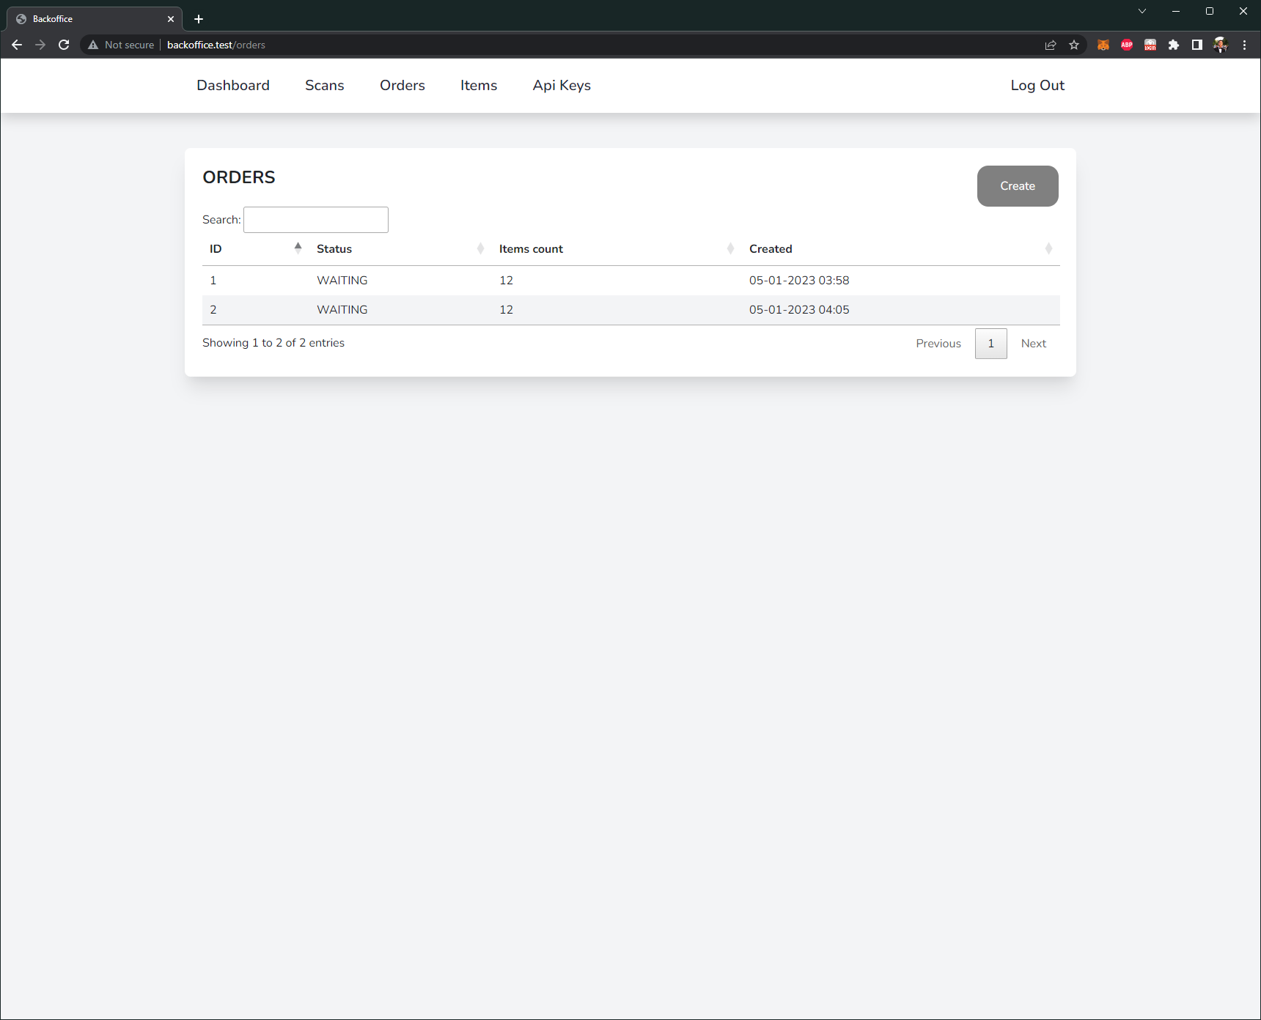

Figure order index view

Order show view

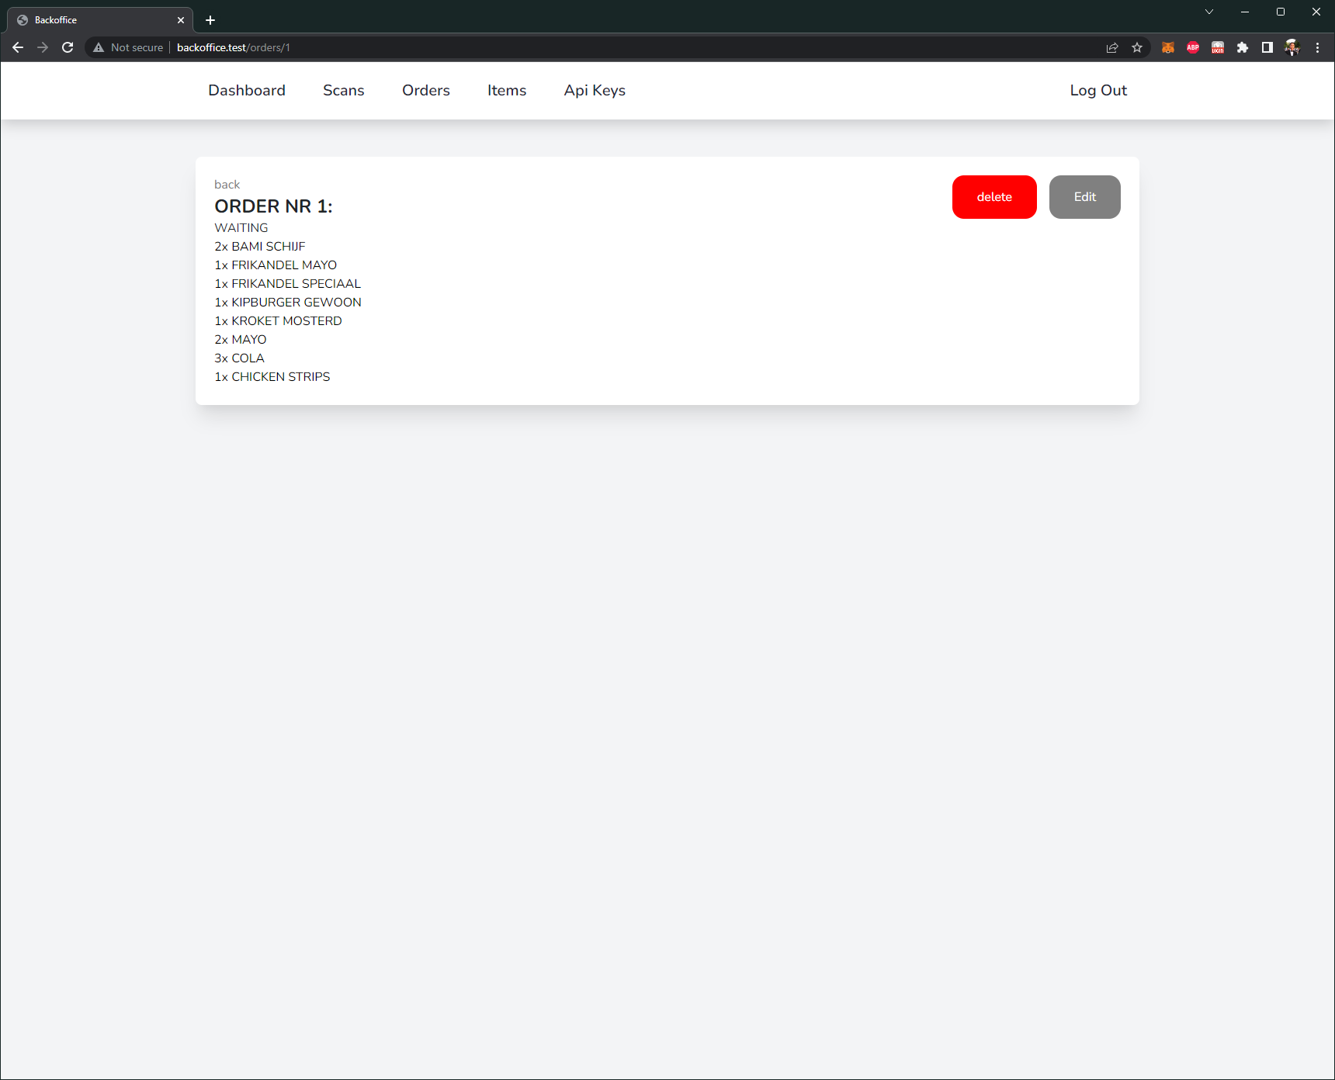

Figure order show view

Order form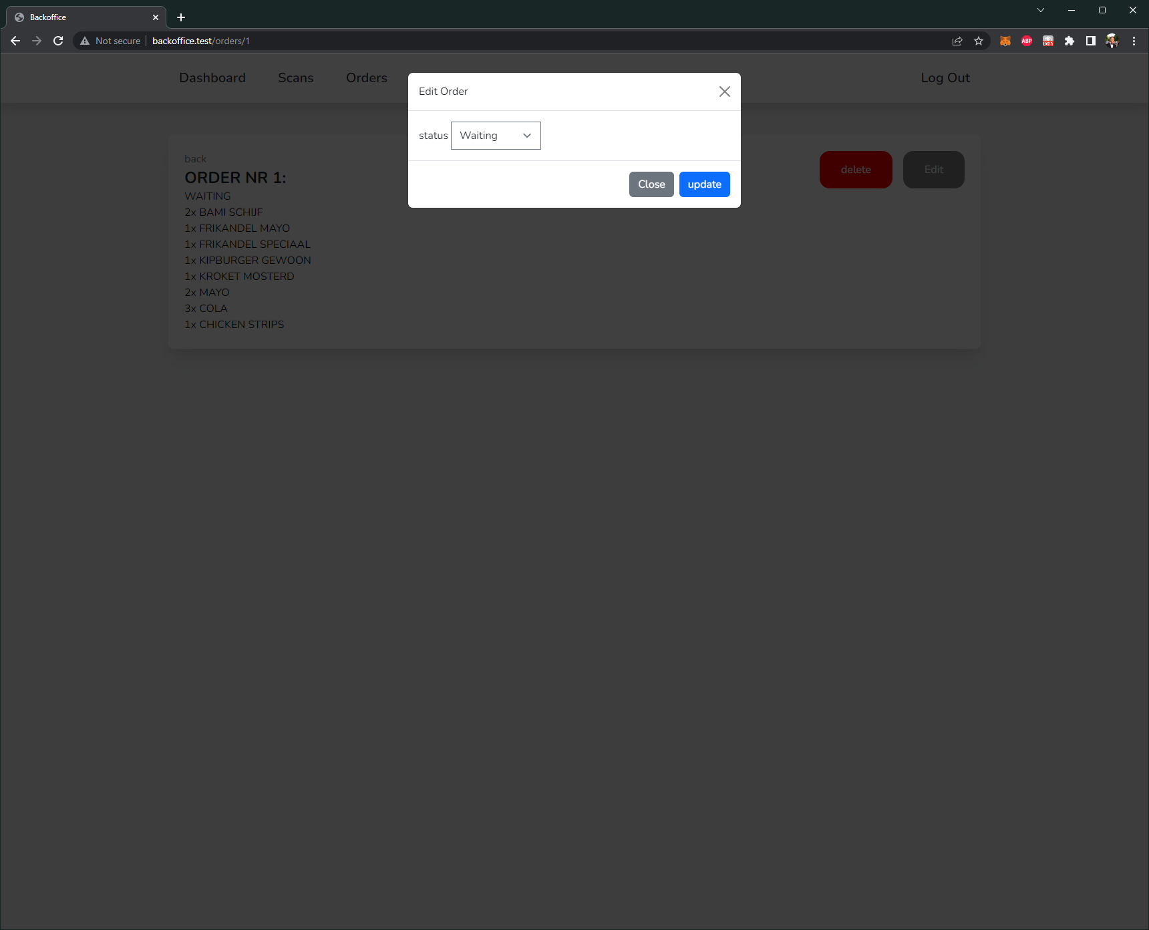

Figure order form

Items index view

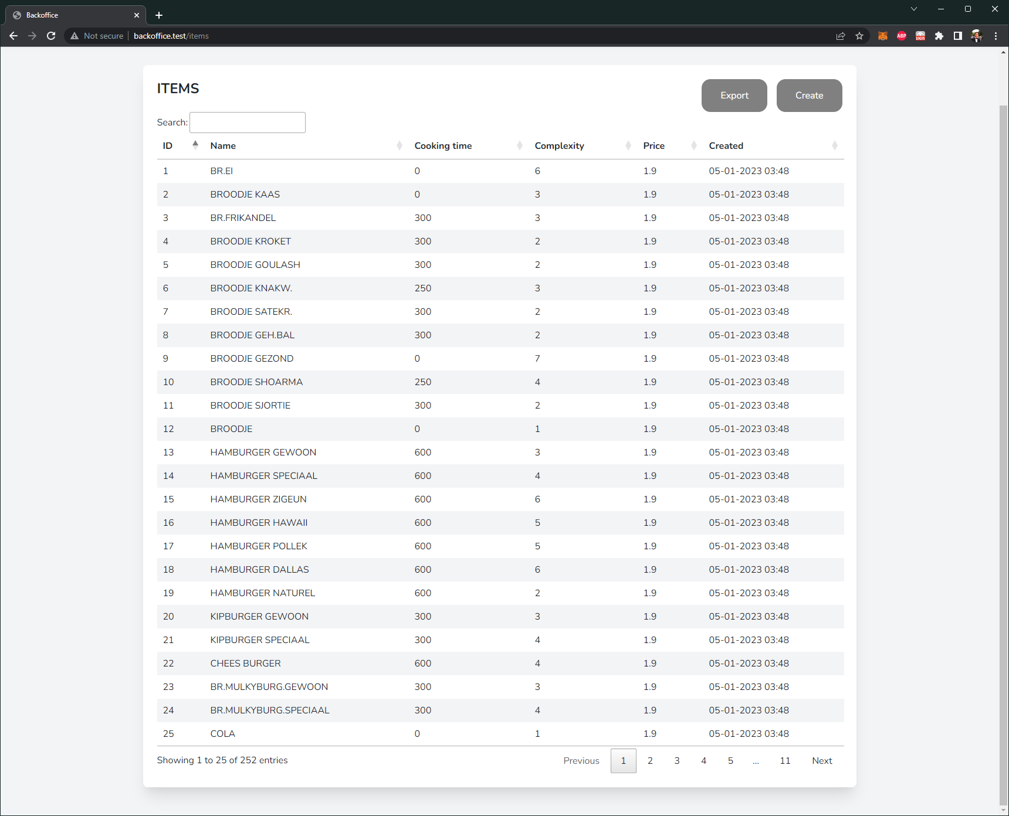

Figure items index view

Items show view

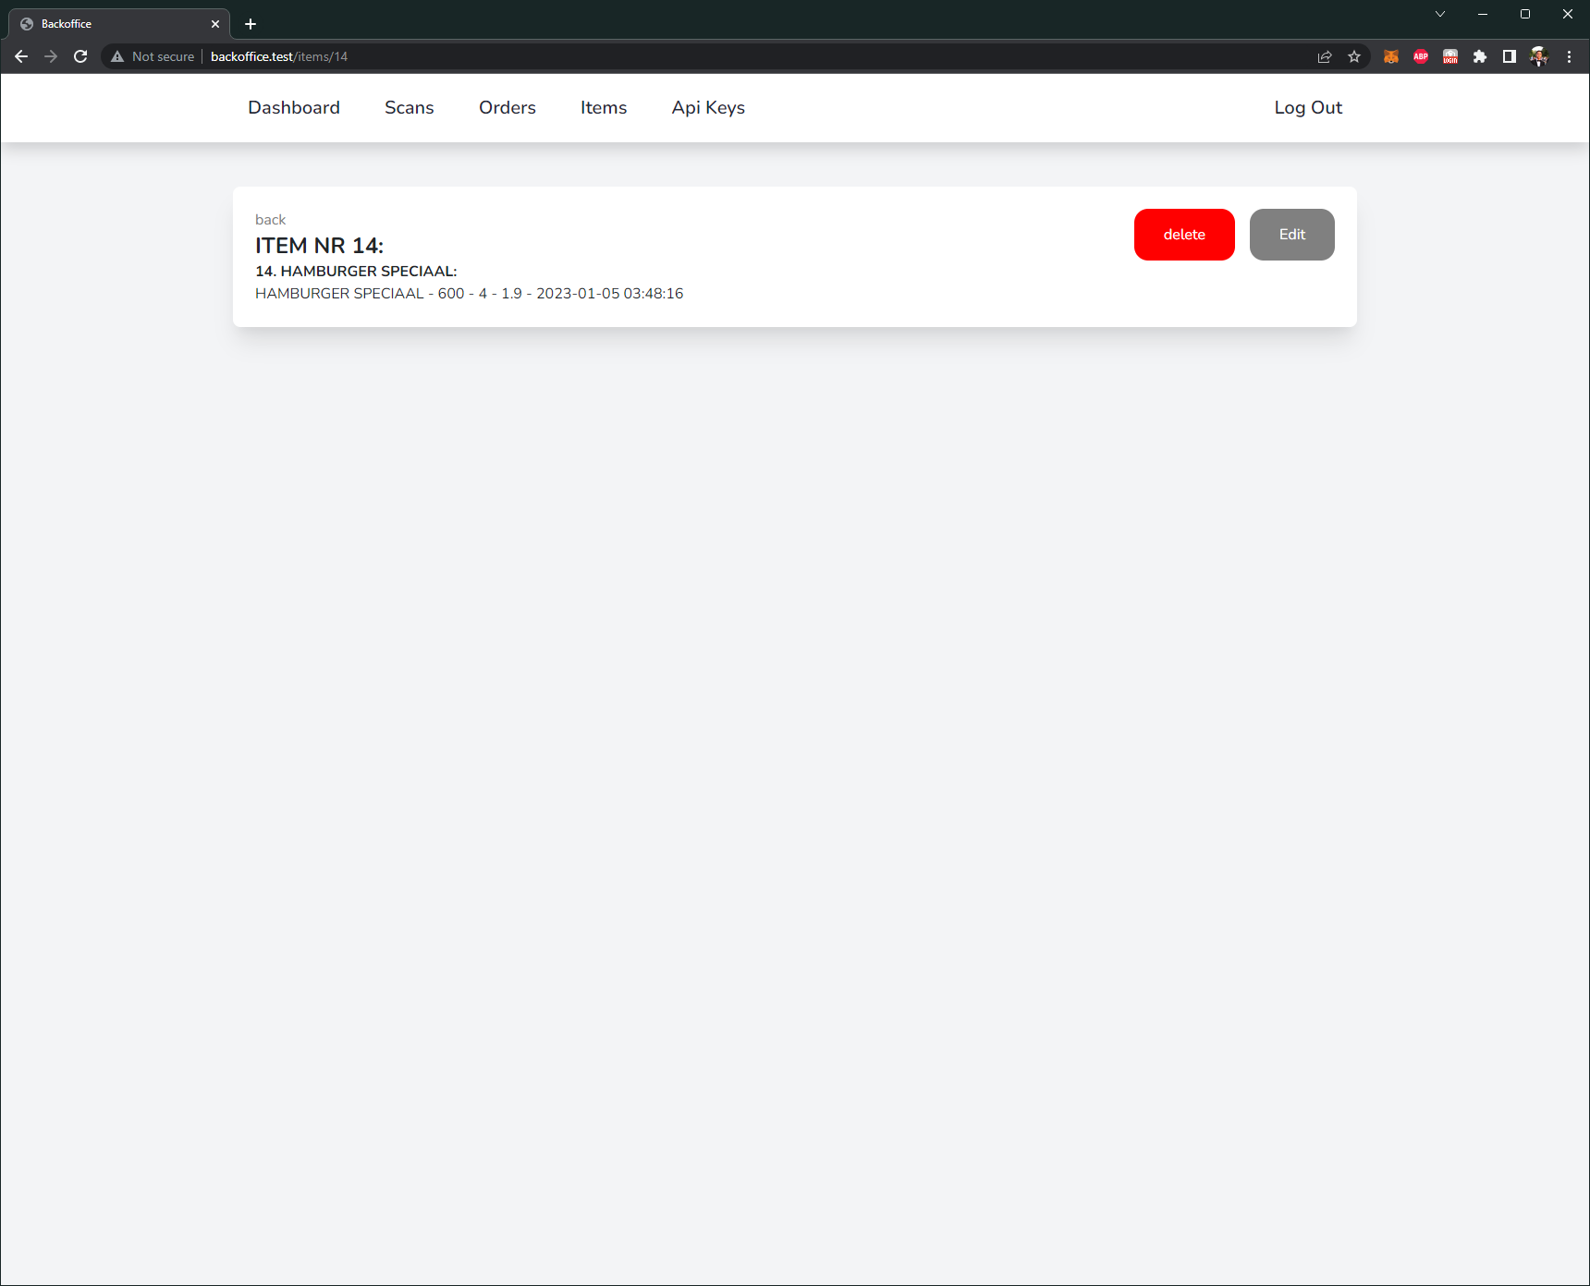

Figure items show view

Items form

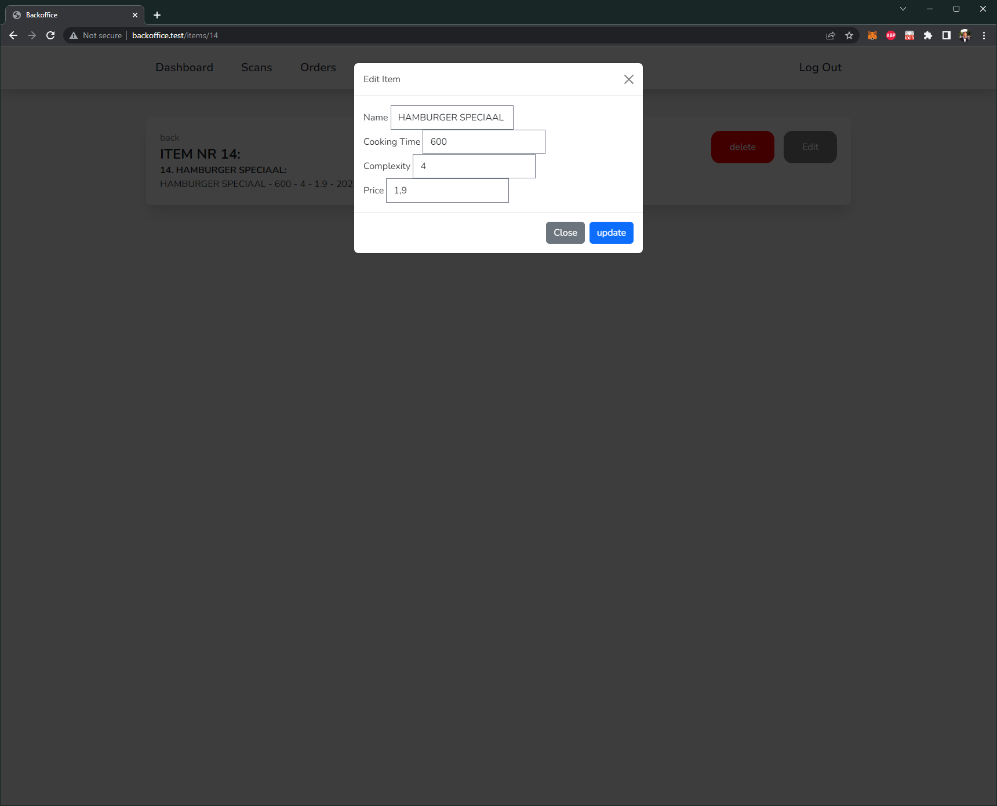

Figure items form

This is the completed prototype of the Backoffice. The dashboard can connect to this platform to receive the most recent data.

## Dashboard

The dashboard will be in the hands of the employee who has to prepare orders. It is created with React.js and will be displayed on an iPad which can be mounted. This results in no hinderance in mobility or working space.

#### Functions

The main functionality of the dashboard is to assist the employee with preparing orders. The dashboard currently looks like the following:

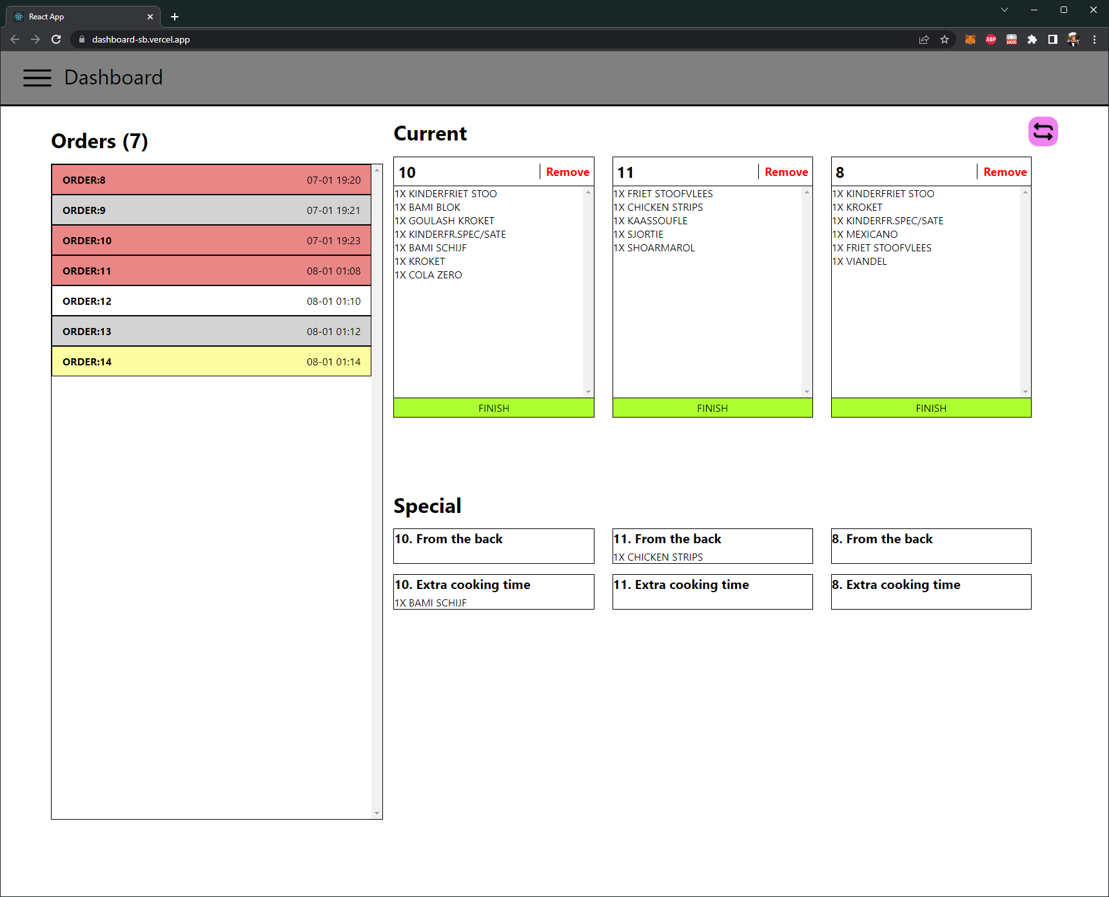

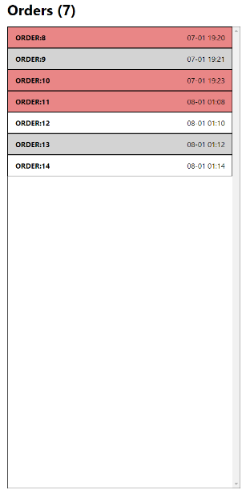Figure Dashboard view

Figure order list

On the left side are all the orders with the status: “*WAITING*”.

These orders still have to be prepared, and can be clicked on to move them to the Current orders.

If the row is red, it means it is selected and already in the current orders block.

If it is white/grey, it is a normal order without any special items.

If the order is light yellow, it is an order that required special attention.

On the right side, the current/selected orders are displayed, up to a maximum of 3 orders.

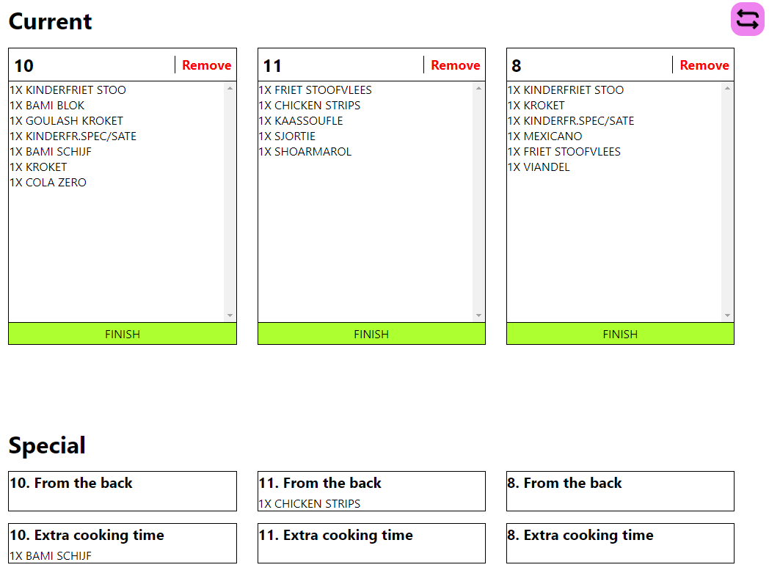

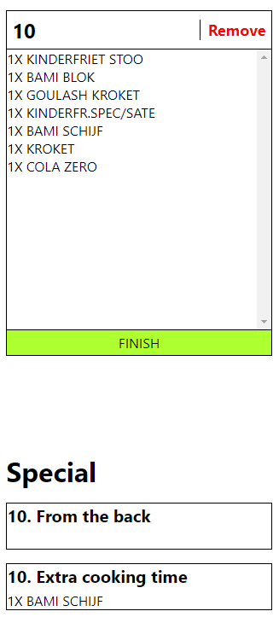Figure right side dashboard

Figure one order current side

Each order gets displayed in a box, together with the specials notes below them.

The order box is split into 3 sections: the top part, middle, and bottom.

In the top part, the order ID is displayed, together with a button to remove/deselect the order. The order gets placed back into the previous order list.

The middle part has the order itself. The items linked to the order are displayed in this box.

Finally, the FINISH button. This button can be pressed when the employee is finished with preparing the order. The order status then gets updated to IN_PROGRESS.

Below the order box, the special items are displayed.

The from the back box displays all the items that are not in the front deli case and have to be gathered from the back fridge.

The extra cooking time displays items that have to be dropped into the frying pan earlier than other snacks (usually snacks that take longer than 5 minutes).

The swap button on the top right can be pressed to see the orders that have been finished.

Figure swap button

This results in the same screen, but with orders that have a different status than “*WAITING*”. Instead of the “FINISH” button, there is the “RETURN” button. This button puts the order status back to “WAITING”, incase “*FINISH*” was pressed accidentally.

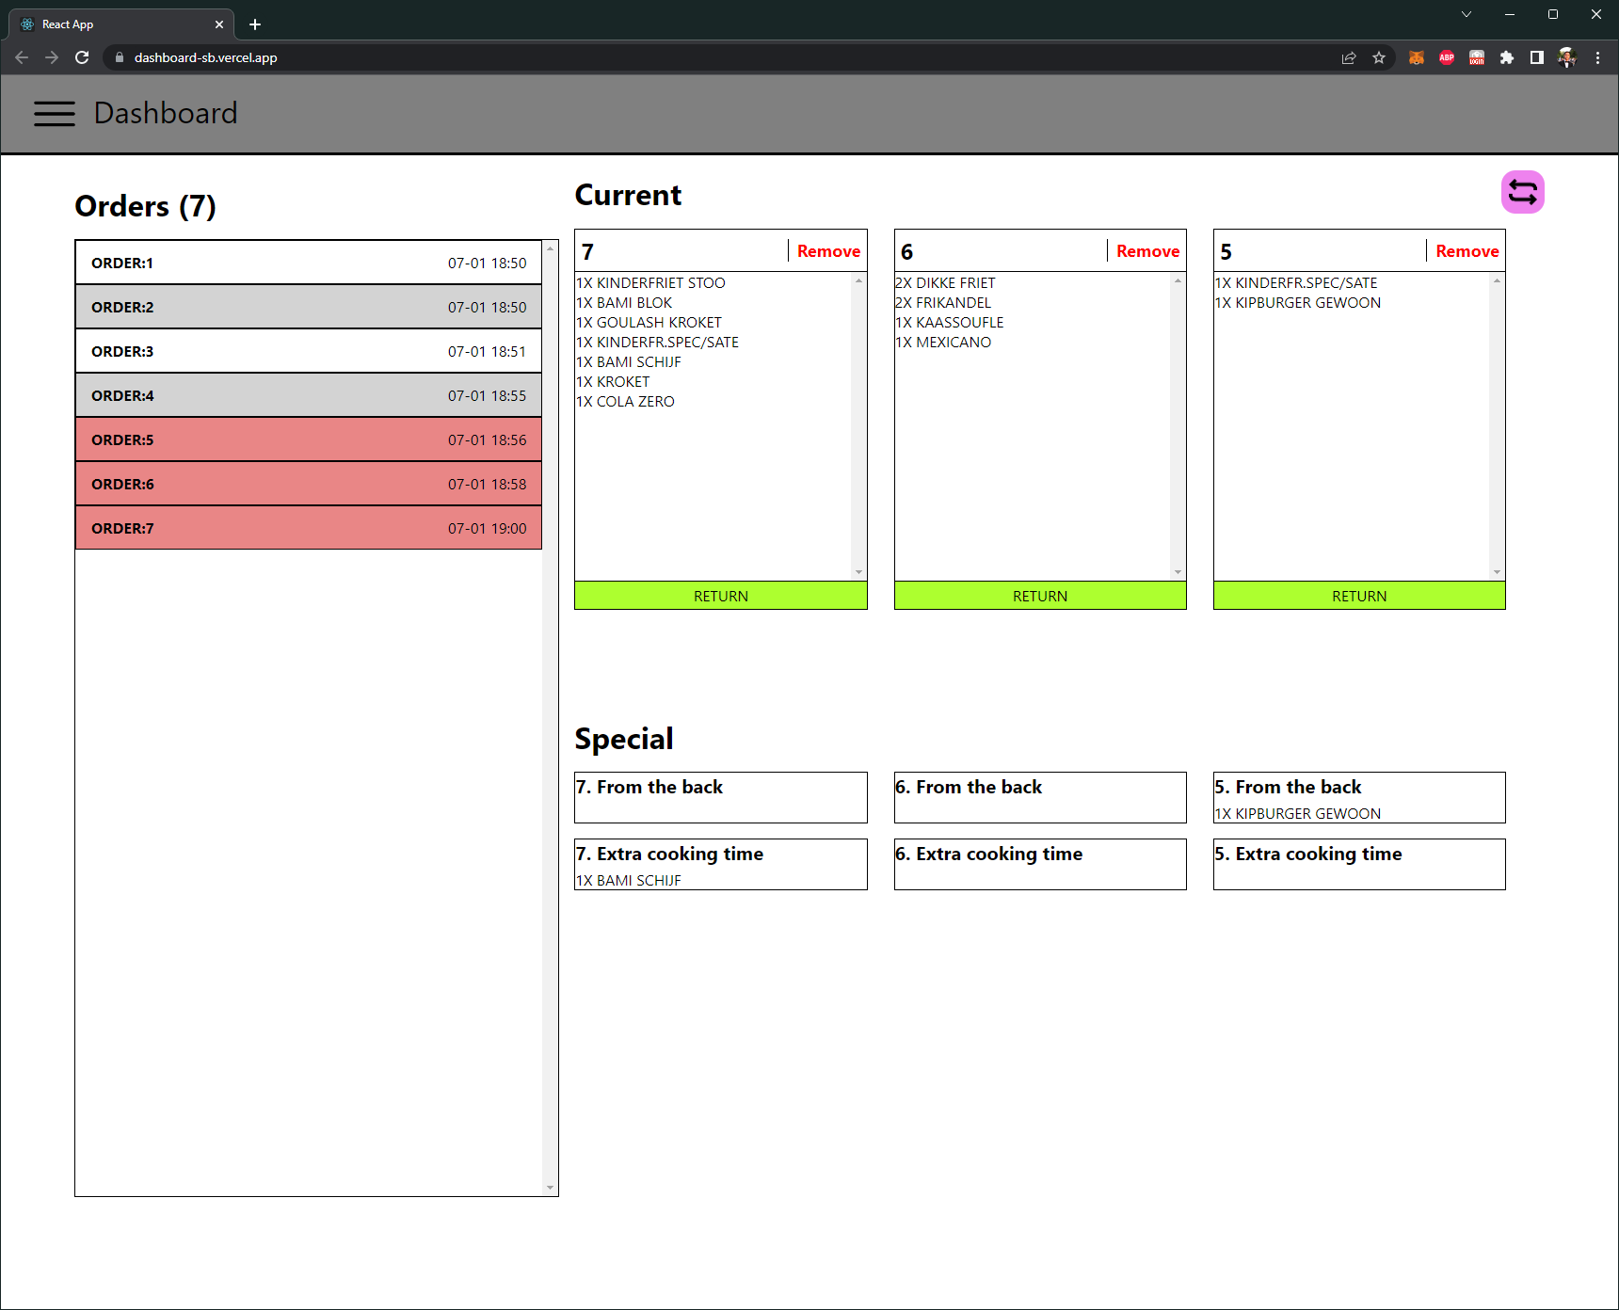

Figure non waiting orders

## Hosting

To be able to use the system everywhere, and not just locally, the applications have to be hosted. Mainly the Backoffice and Dashboard, since the Raspberry Pi and camera are hardware.

#### Backoffice

The Backoffice is hosted using Digital Ocean. It unfortunately is not free, but hosting Laravel applications for free has gotten harder, since the free plan for Heroku got removed. Fortunately, Digital ocean works well, and students get free credits to play around with.

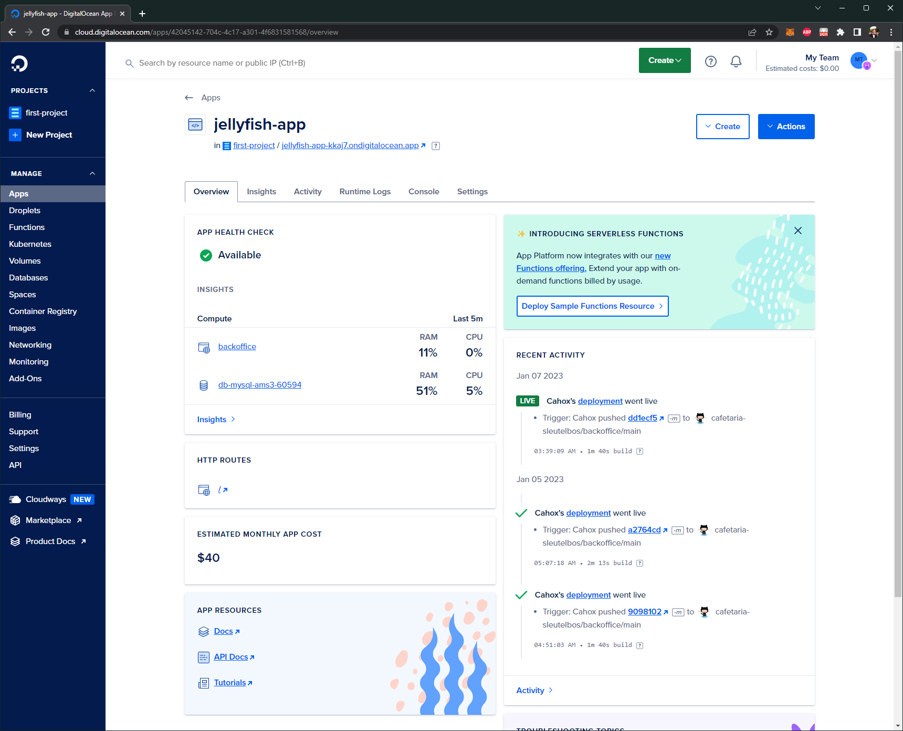

Figure Digital Ocean

The application is linked to GitHub, so on every push to the main branch, it automatically updates.

The hosting consists of 2 parts: The Backoffice itself, and the database. The website of the hosted application can be found here: <https://jellyfish-app-kkaj7.ondigitalocean.app/>

To login, you can use the test account.

Email: [admin@admin.admin](mailto:admin@admin.admin)

Password: password

#### Dashboard

The Dashboard is hosted on Vercel. 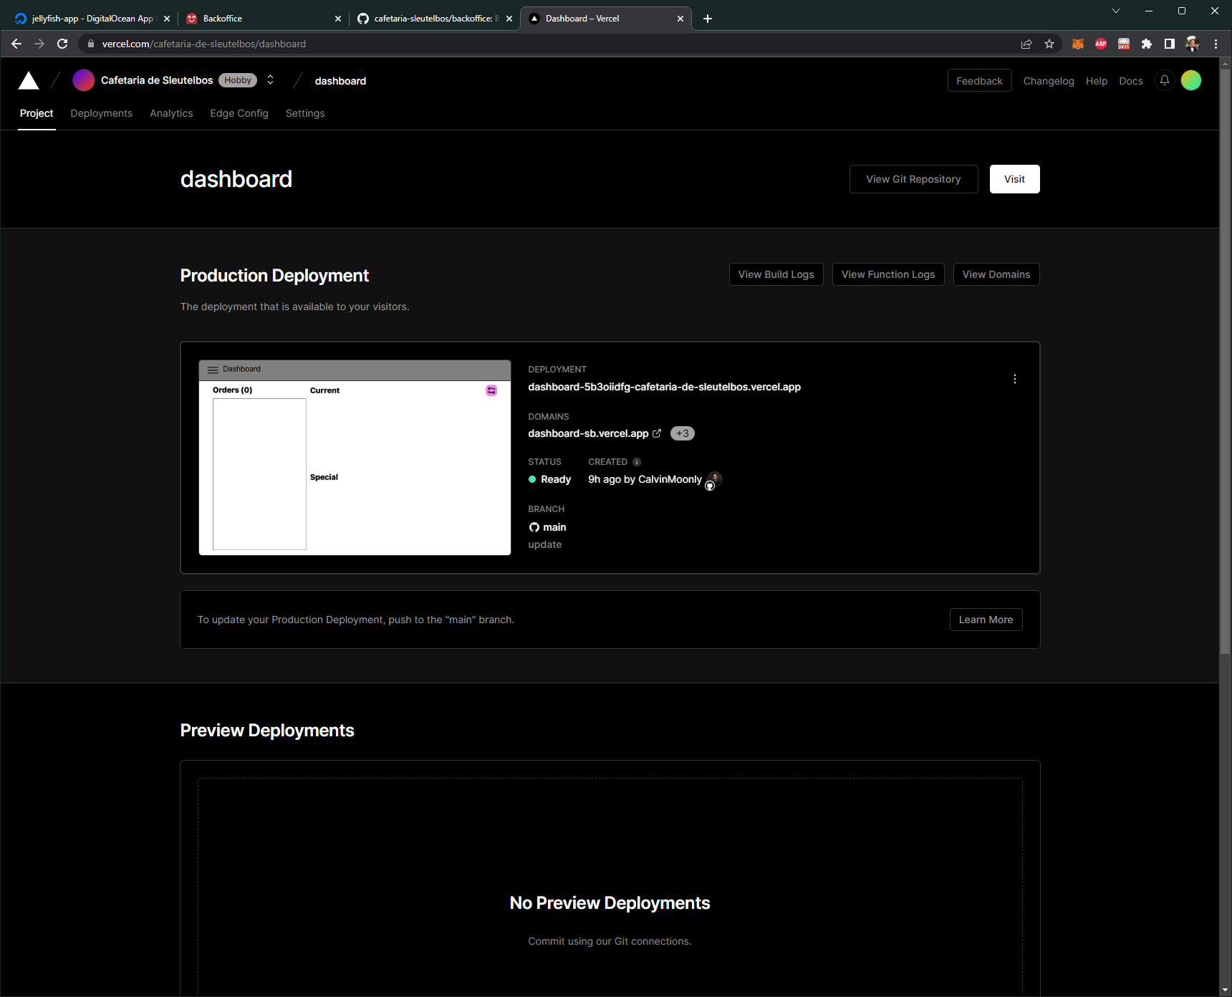

Figure Vercel

Vercel is free and can handle Node projects. Like Digital Ocean and many other hosts, the deployment automatically fires after each push to the main branch.

The website can be found here: <https://dashboard-sb.vercel.app/>

# GitHub links

The actual work can be found in GitHub repositories. These repositories are all public and part of the GitHub Organization: **cafetaria-sleutelbos** (<https://github.com/cafetaria-sleutelbos>)

##### Documents

All the documents, including this one, can be found in the GitHub repository: <https://github.com/cafetaria-sleutelbos/Documents>

##### Backoffice

The GitHub repository for the Backoffice can be found here:

<https://github.com/cafetaria-sleutelbos/backoffice>

##### Dashboard

The GitHub repository for the Dashboard can be found here:

<https://github.com/cafetaria-sleutelbos/dashboard>

#### Scanner

The scanner is hardware and there is only one version/prototype of it, so there is no point in hosting it currently. However, the code in the GitHub repository can be found here:

<https://github.com/cafetaria-sleutelbos/scanner>

# Live Action

The system has been testing live in the snack bar. The basic setup looked like this:

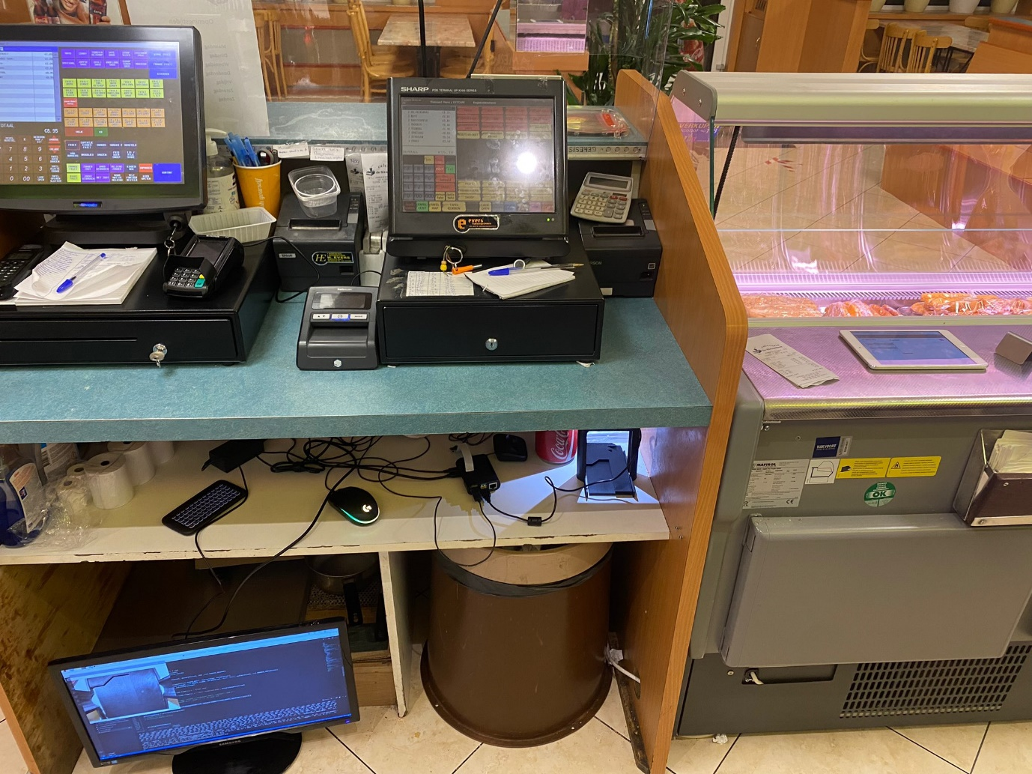

Figure General live setup

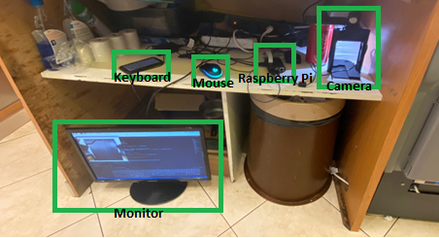

Figure setup with titles

With a demo video:



Figure demo video

Unfortunately, the system still has to be improved to be actually functional during rush hours.

# Follow up suggestions

First of all, the styling of the Backoffice and Dashboard could use some more attention. The UX could be improved and the colors and layouts are inconsistent. However, this was to be expected, since the styling was not a priority during this project. Furthermore, the process of scanning a receipt is hard to do. The 3D models could be improved so that sliding in the receipt is easier. The setup with the Raspberry Pi works good, but the fact that a monitor is needed is a big negative point. Overall, with some minor improvements, the project could start handling some smaller rush hours.

This project created the basic framework for multiple more add-on/extension projects.

* Use AI and camera to see which snacks are gone in the displays
* New dashboards for all stations
* Updatable Digital Signage
* Order Status Board
* Overview statistics screen

# Conclusion

To conclude, a system was made to assist an employee with the task of preparing orders. This was done by creating a system that consists out of three main parts: A scanner, Backoffice, and Dashboard. The system would help the employee by showing what items should be fried earlier, and which items have to be retrieved from the back. The current system can be improved further and new projects can be linked/connected.

The system was tested in a live environment inside the snack bar, but unfortunately it is not up to par yet to be used during rush hours.